**This week I focused on how to get the Workflow Max auth, and how to send the requests to Workflow Max.**

**Why use php send request to Workflow Max?**

When Use Vue fetch method send request to Workflow Max.

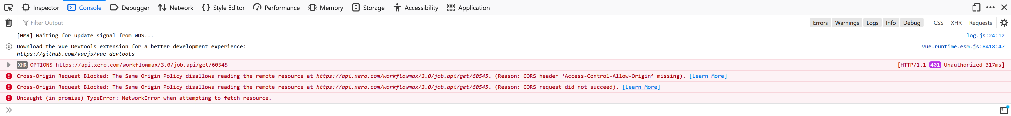

Google answer:

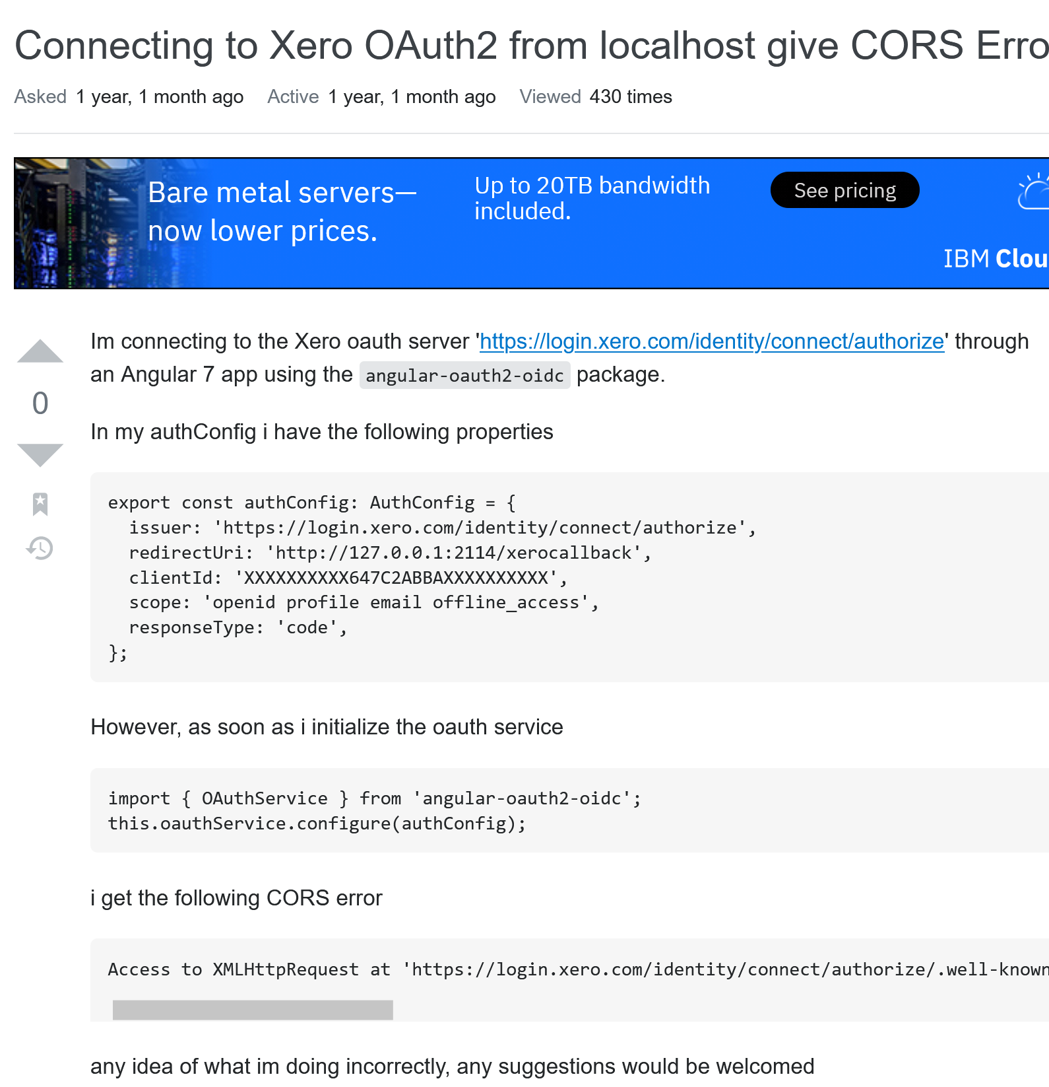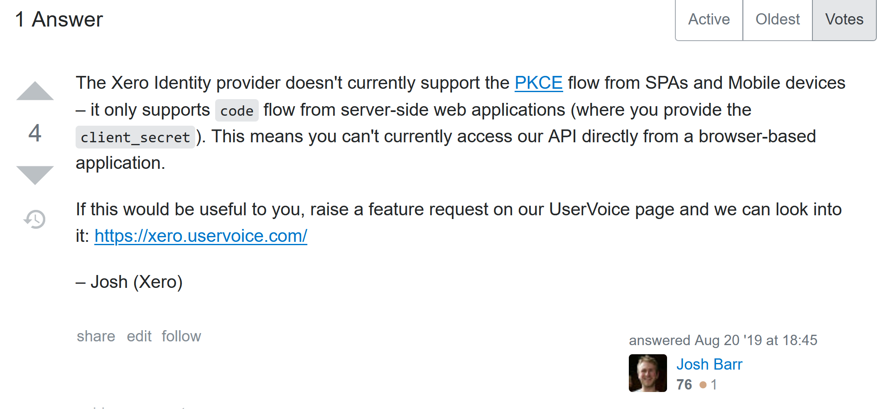

Ref: <https://stackoverflow.com/questions/57579323/connecting-to-xero-oauth2-from-localhost-give-cors-erros>

1. How to get workflow max token with our program.

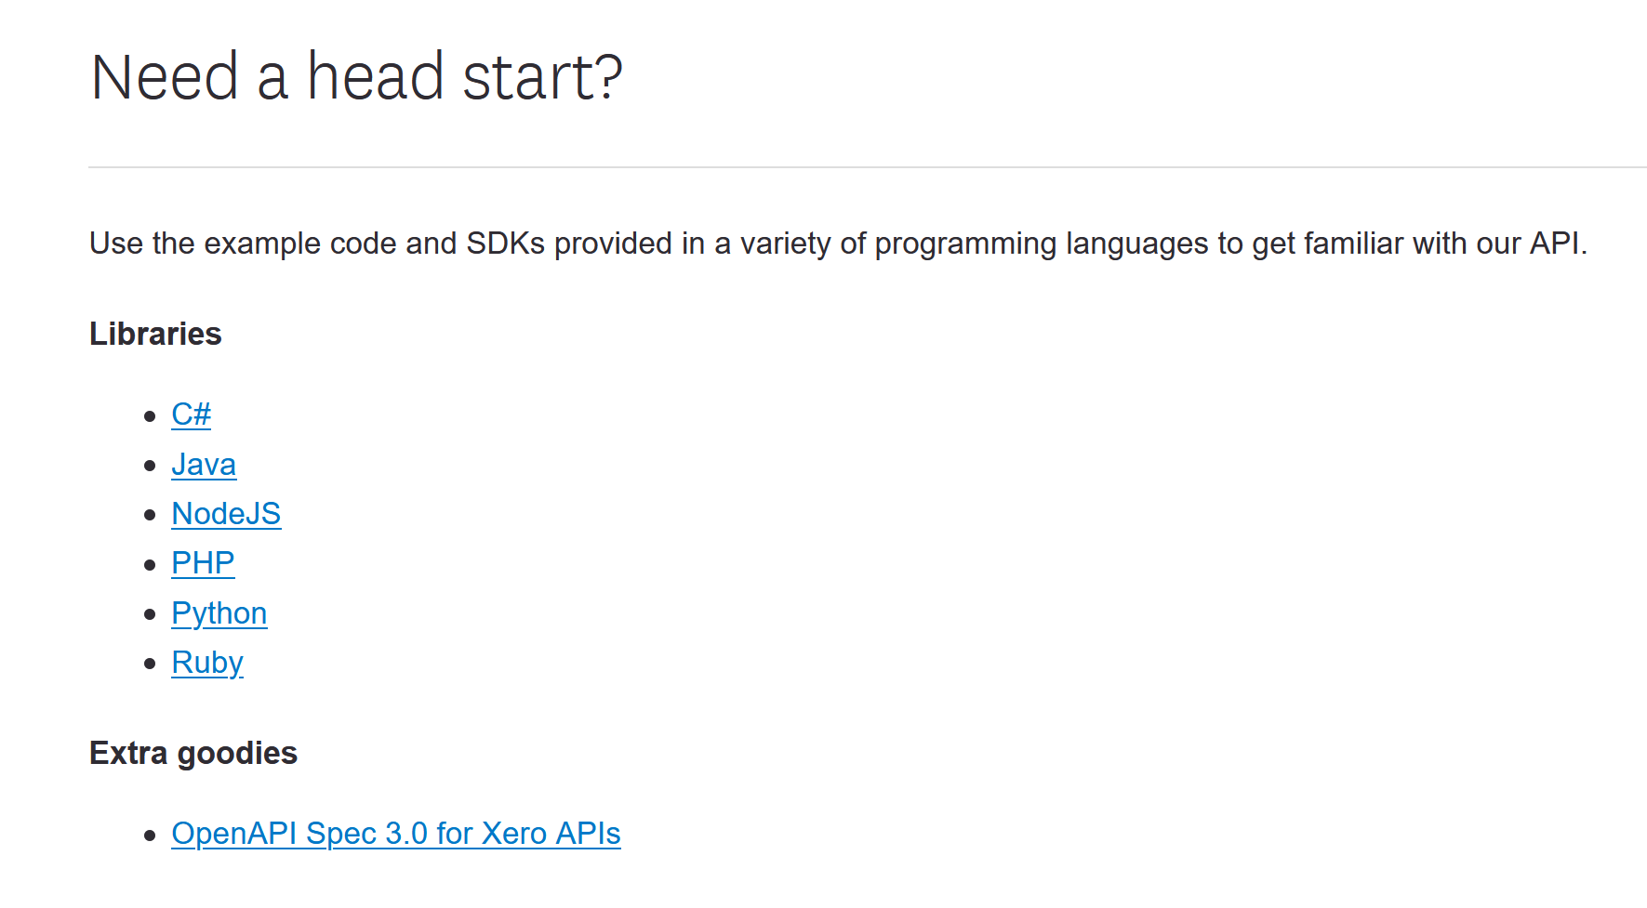

Ref: <https://developer.xero.com/documentation/libraries/overview>

1. I decided to use PHP to develop the back end. Then I decided to use Laravel framework to get the workflow max’s token.
2. Install WAMP
3. Install Composer
4. Create Laravel project

composer create-project --prefer-dist laravel/laravel Ossis

1. Config Apache v-host

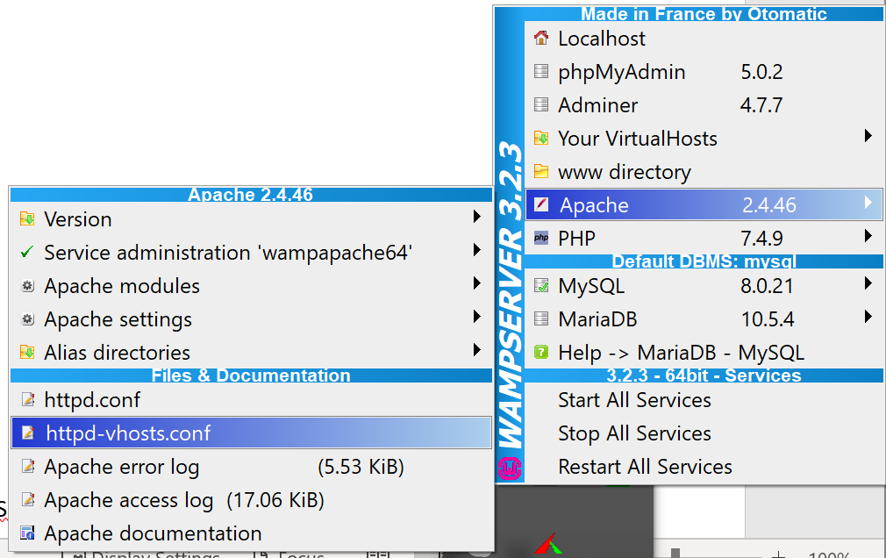

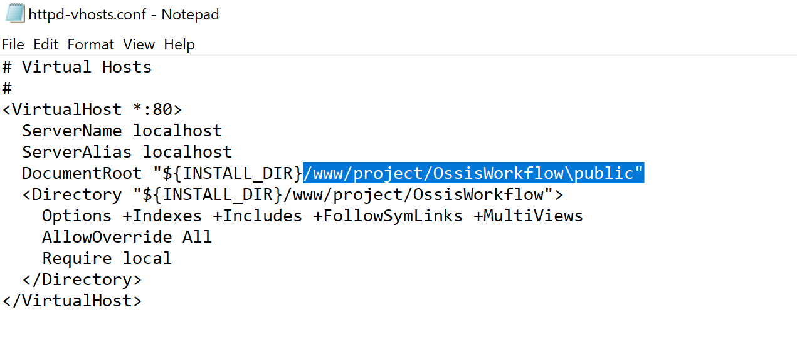

1. Install Guzzle HTTP client.

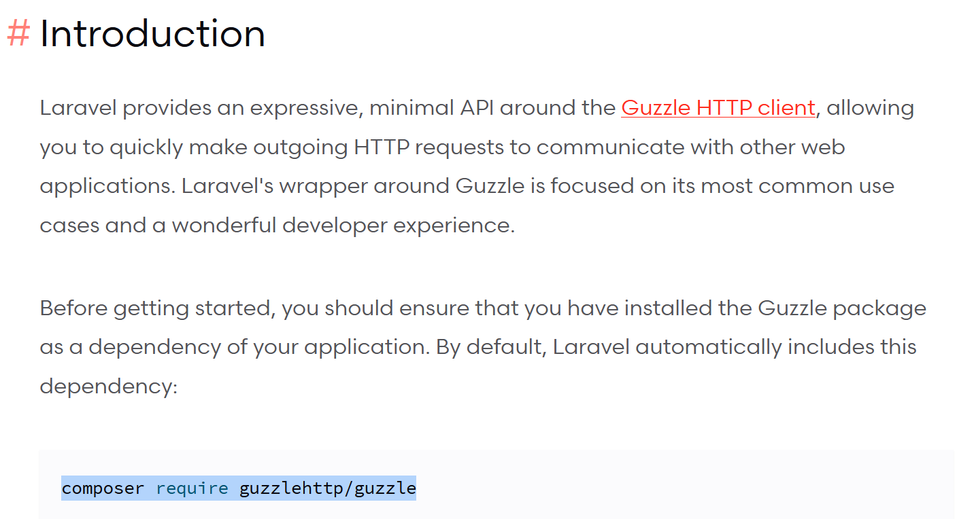

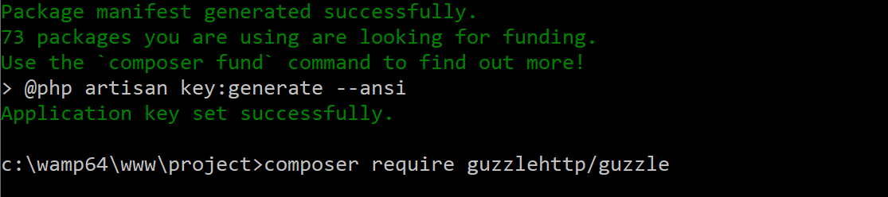

1. Follow youtube：https://www.youtube.com/watch?v=UYRYlXhdxGU
2. Add the xero-php-oauth2 sdk to composer.json

composer require xeroapi/xero-php-oauth2

1. Add link for testing on welcome.blade.php,

<a href="authorization.php"> Connect to Xero</a>

1. copy/paste the code below into 4 separate PHP files and substitute your **ClientId, ClientSecret and RedirectURI**

ref: <https://github.com/XeroAPI/xero-php-oauth2>

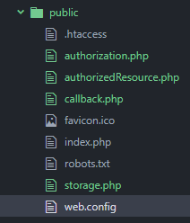

1. update Redirect URL, ClientId， ClientSecret to 3 separate PHP files (authorization,callback, authorizedResource)

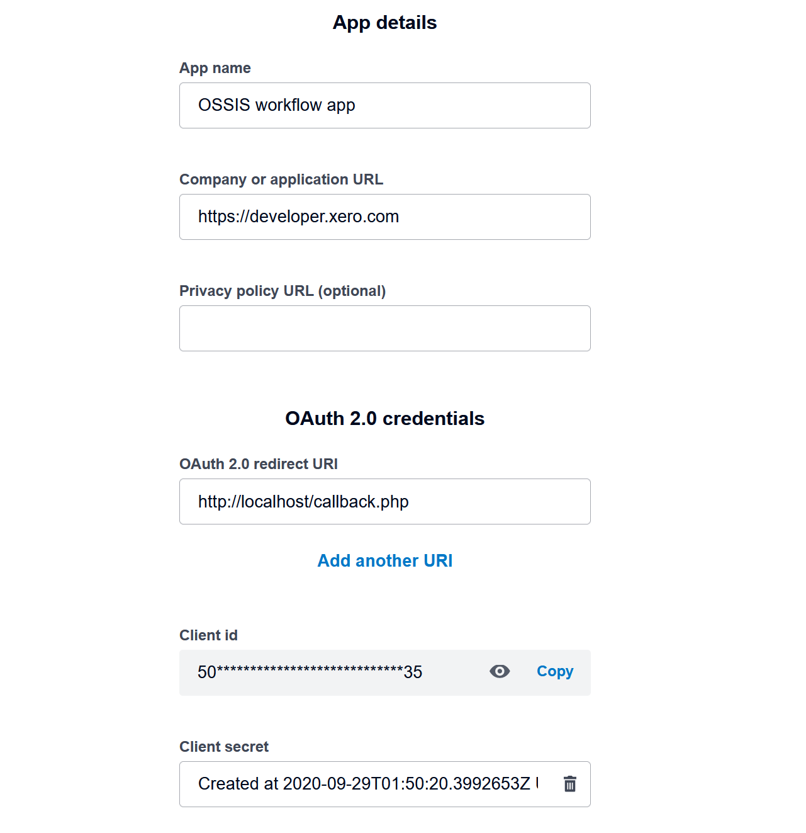 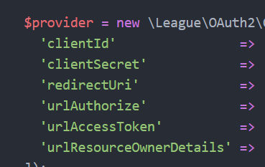

update Redirect URL, ClientId， ClientSecret

1. refresh Webpage. Click Connect to Xero

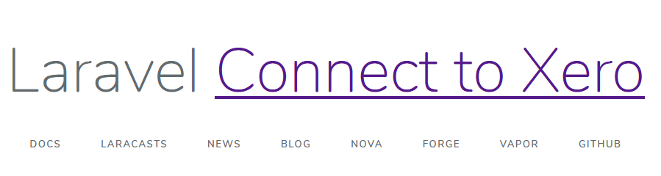

received error as below. Path issue.

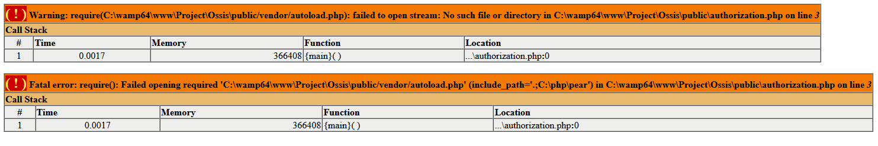

How to fix?

Update autoload.php path on three files.

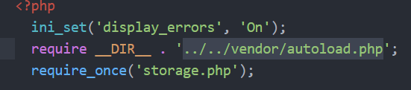

1. refresh page. This page appears below.

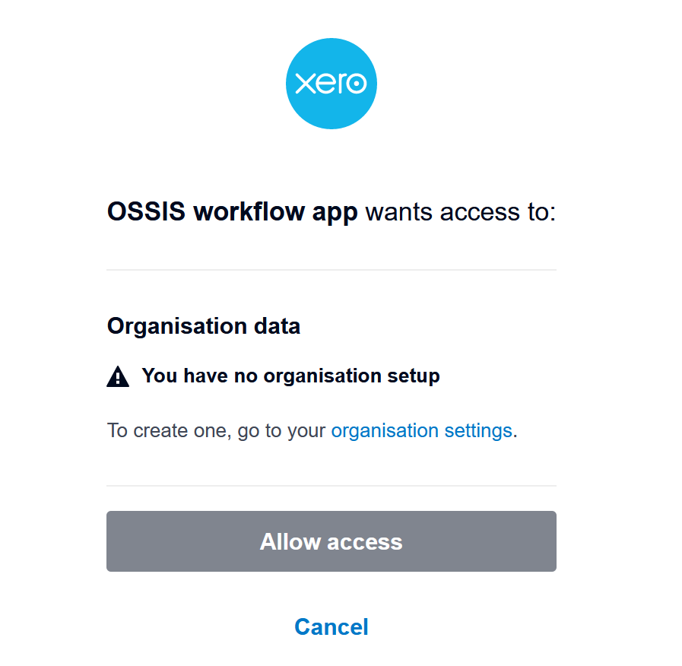

How to fix? Compare with postman, I found that I missed “scope”.

Config scope in authorization.php as below.

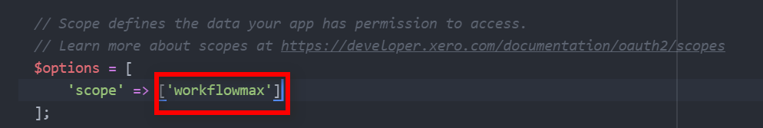

1. refresh page. (should see login page)

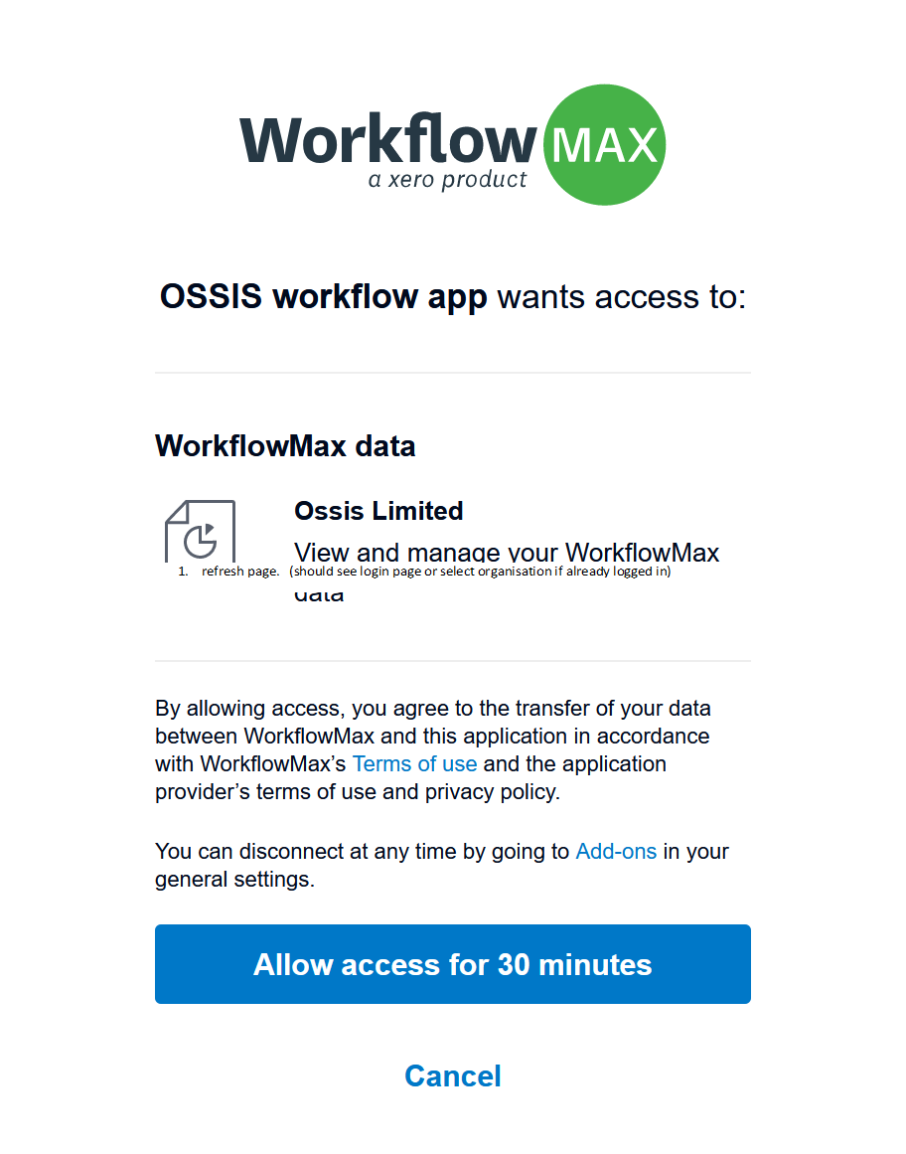

When click the button, new error appears.

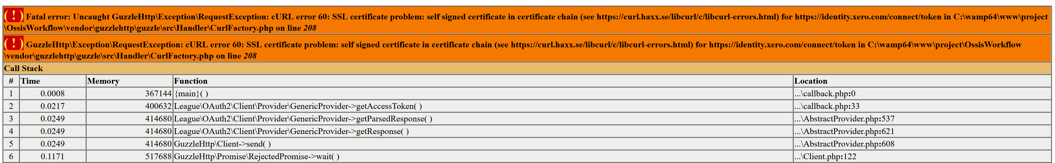

How to fix: Googled find below info.

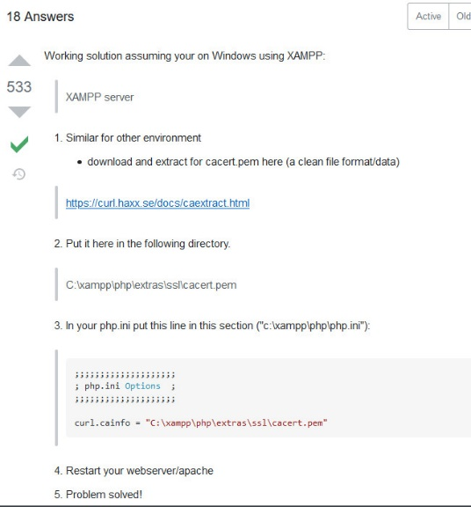

Ref: <https://stackoverflow.com/questions/29822686/curl-error-60-ssl-certificate-unable-to-get-local-issuer-certificate>

Config on my PC

1. Download cacert and copy to local folder.

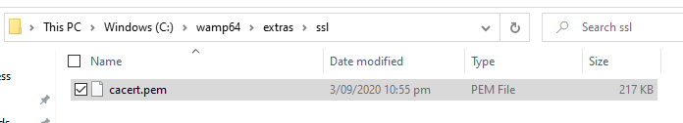

1. Update php ini file:

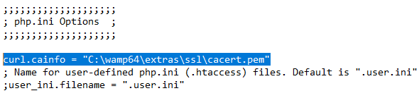

1. Restart Apache
2. Refresh webpage.
3. Re-login, new error appeared.



How to fix?

Remove “()” on line 156 from authorizedResource.php

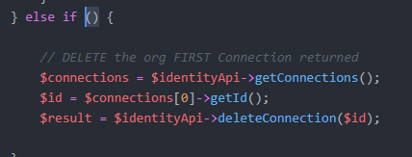

To:

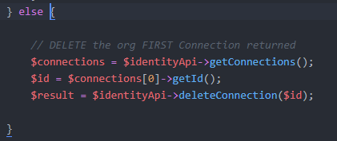

Refresh web page. Can receive below info.

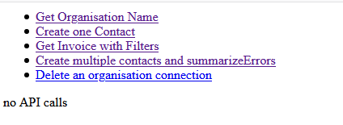

1. Test the token, Can get Token from Callback.php

